# OUTPUT: For Combined 3 types of sorts in a program, I use “switch case” in the program to show result each sort separately. I have used 5 options by “switch case” operation.

Option 1 press: show result from Ascending, Descending, random to Insertion ascending sort :

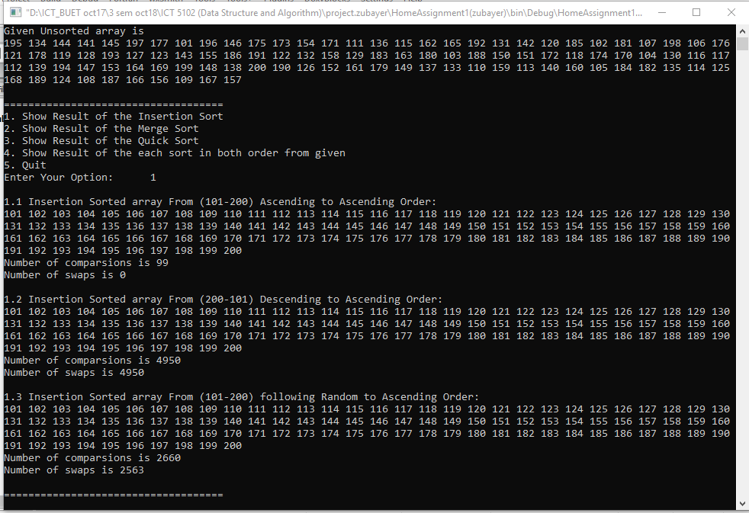

Option 2 press: show result from Ascending, Descending, random to Merge ascending sort :

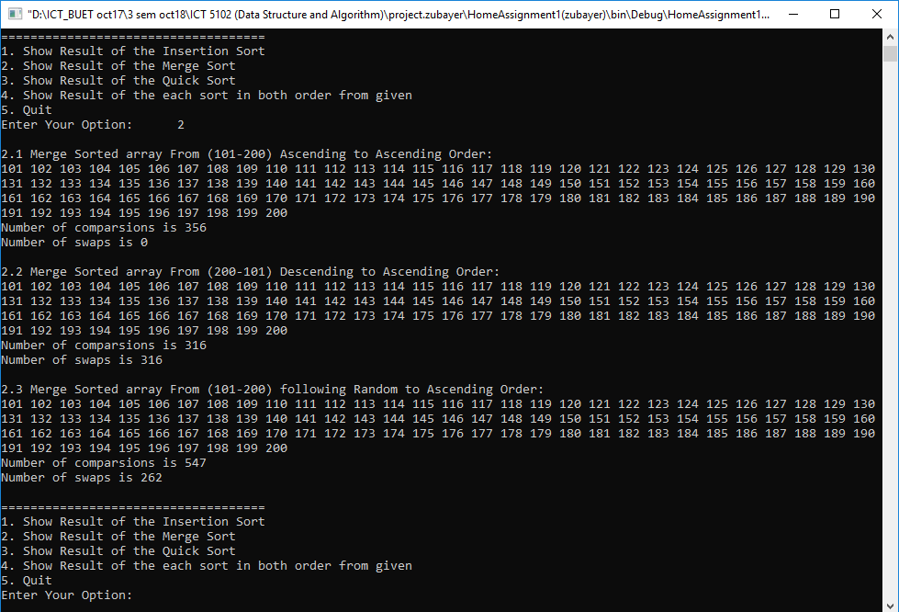

Option 3 press: show result from Ascending, Descending, random to Quick ascending sort :

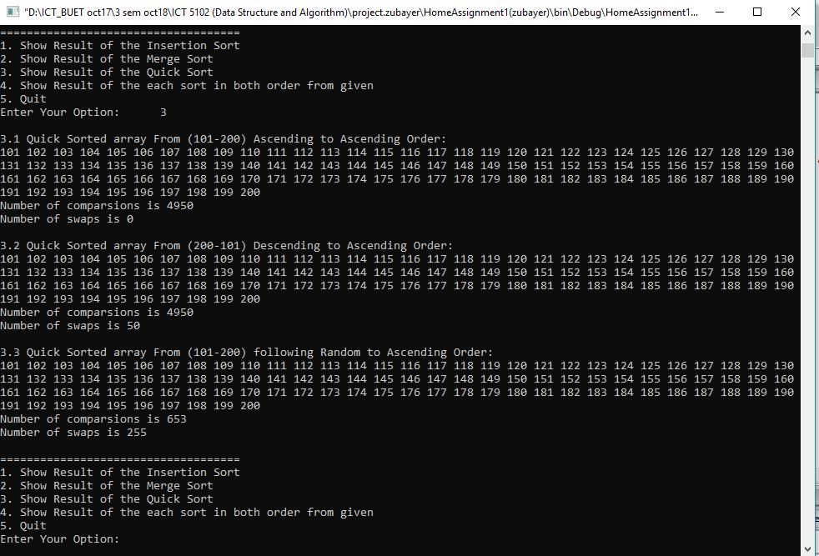

Option 4 press:show result from random to Ascending, Descending of Insertion, Merge, Quick sort :

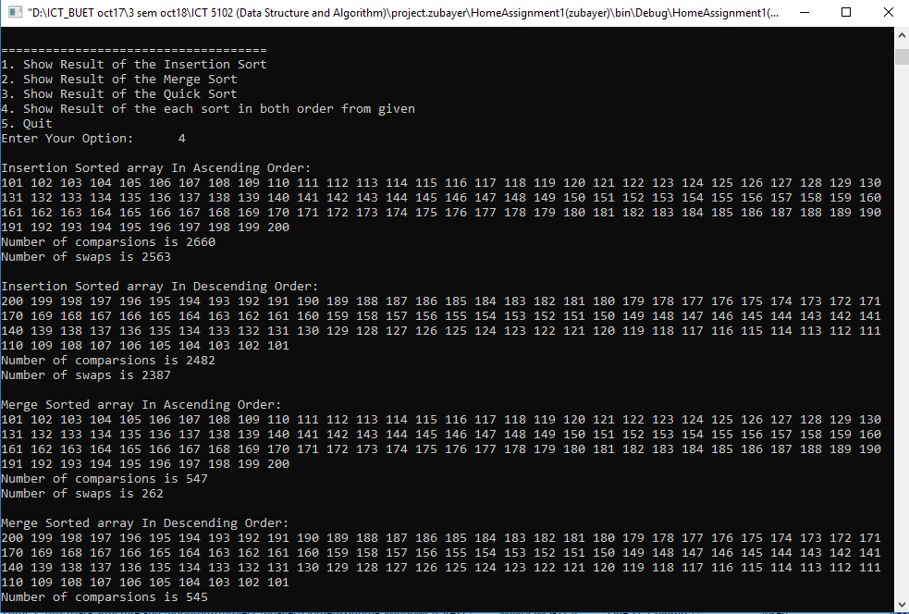

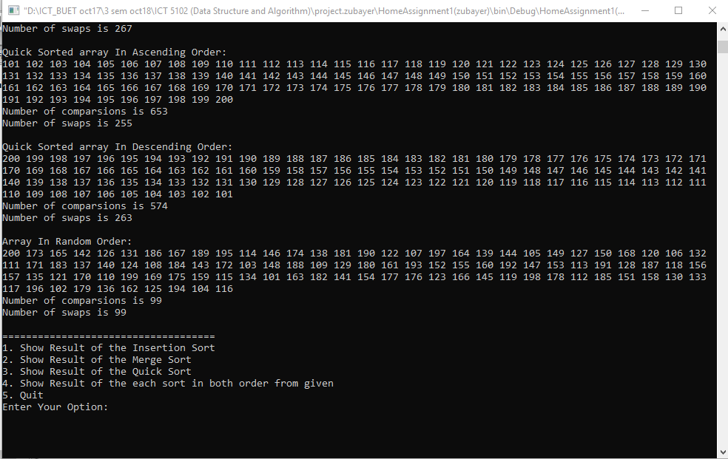

Option 4 press: to Quit program.

# OUTPUT DATA REPORT FOR COMPARISONS & SWAPS COUNT:

|  |  |  |  |
| --- | --- | --- | --- |
| ALGORITHM | IN Order | NO OF COMPARISONS | NO OF SWAPS |
| **Insertion Sort** | From (101-200) Ascending to Ascending Order | 99 | 0 |
| From (200-101) Descending to Ascending Order | 4950 | 4950 |
| From (101-200) following Random to Ascending Order | 2660 | 2563 |
| **Merge Sort** | From (101-200) Ascending to Ascending Order | 356 | 0 |
| From (200-101) Descending to Ascending Order | 316 | 316 |
| From (101-200) following Random to Ascending Order | 547 | 262 |
| **Quick Sort** | From (101-200) Ascending to Ascending Order | 4950 | 0 |
| From (200-101) Descending to Ascending Order | 4950 | 50 |
| From (101-200) following Random to Ascending Order | 653 | 255 |